Chapter 3, Solution 91
For the transistor circuit of Fig. 3.127, find I_{B}, V_{CE}, and v_{o}. Take β = 200, V_{BE} = 0.7V.

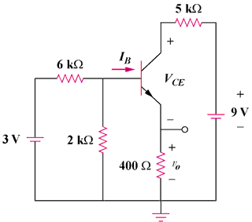

Figure 3.127
For Prob. 3.91.

Solution
We first determine the Thevenin equivalent for the input circuit.
R_{Th} = 6||2 = 6x2/8 = 1.5 kΩ and V_{Th} = 2(3)/(2+6) = 0.75 volts

+
V₀
–

400 Ω
-

+

9 V
-

+

i₁

i₂
+
V_{CE}
–

+
V_{BE}
–

I_{B}

I_{E}

1.5 kΩ

5 kΩ

0.75 V

I_{C}

For loop 1, -0.75 + 1.5kI_{B} + V_{BE} + 400I_{E} = 0 = -0.75 + 0.7 + 1500I_{B} + 400(1 + β)I_{B}

I_{B} = 0.05/81,900 = 0.61 μA

v₀ = 400I_{E} = 400(1 + β)I_{B} = 49 mV

For loop 2, -400I_{E} – V_{CE} – 5kI_{C} + 9 = 0, but, I_{C} = βI_{B} and I_{E} = (1 + β)I_{B}

V_{CE} = 9 – 5kβI_{B} – 400(1 + β)I_{B} = 9 – 0.659 = 8.641 volts

